BOOKSTORE DATA
  - SQL Queries

1) Retrieve all books in the "Fiction" genre
SELECT title FROM books
WHERE genre = 'fiction'
Result:
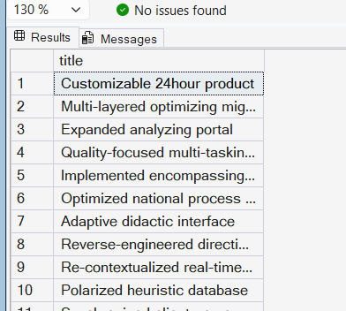

1.a) Retrieve number of fiction books
SELECT COUNT(*) AS fiction_books
FROM books
WHERE genre = 'fiction'
Result:
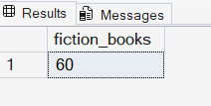
2) Find books published after the year 1950
SELECT * FROM books
WHERE published_year > 1950
Result:
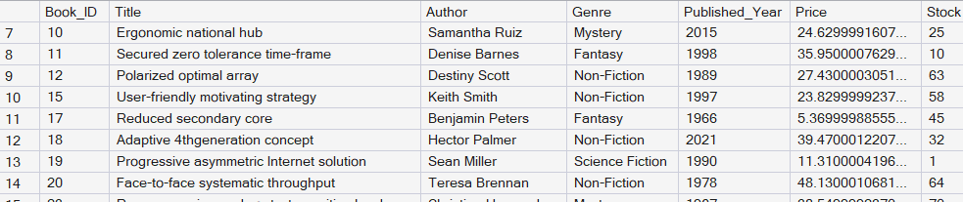
3) List all customers from the Canada
SELECT * FROM customers
WHERE country = 'canada'
Result:
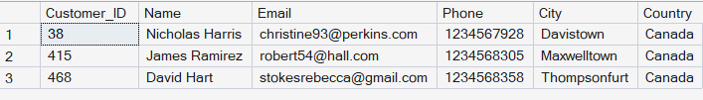

4) Show orders placed in November 2023
SELECT
DATENAME(MONTH, order_date) AS Month,
DATEPART(YEAR,order_date) AS year,
COUNT(order_id) AS orders_placed
FROM Orders
GROUP BY DATENAME(MONTH, order_date),
DATEPART(YEAR,order_date)
HAVING DATENAME(MONTH, order_date) = 'November' AND
DATEPART(YEAR,order_date) = '2023'
Result:
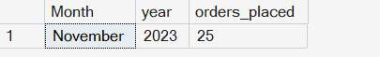

5) Retrieve the total stock of books available
SELECT SUM(stock) AS Total_stock
FROM books
Result:
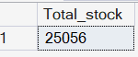

6) Find the details of the most expensive book
SELECT TOP 1 * FROM books
ORDER BY price DESC
OR
SELECT * FROM books
WHERE price= (SELECT
MAX (price) FROM books)
Result:

7) Show all customers who ordered more than 1 quantity of a book
SELECT Customer_ID, quantity FROM orders
WHERE quantity > 1
Result:
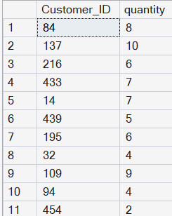

8) Retrieve all orders where the total amount exceeds $20
SELECT * FROM Orders
WHERE total_amount > 20
Result:
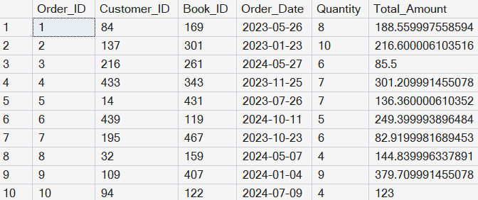

9) List all genres available in the Books table
SELECT genre FROM books
GROUP BY genre
Result:
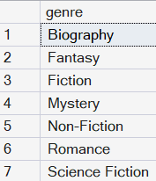

10) Find the book with the lowest stock
SELECT TOP 4 * FROM books
ORDER BY stock ASC
Result:
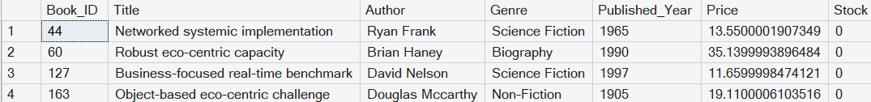

11) Calculate the total revenue generated from all orders
SELECT
FORMAT(SUM(CONVERT(FLOAT,total_amount))/1000,'N2')+ 'k' AS revenue
FROM Orders
Result:
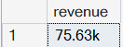

1)Retrieve the total number of books sold for each genre
SELECT b.genre,
SUM(o.quantity) AS books_sold
FROM orders o
JOIN books b
ON b.book_id = o.book_id
GROUP BY b.genre
ORDER BY SUM(o.quantity) DESC
Result:
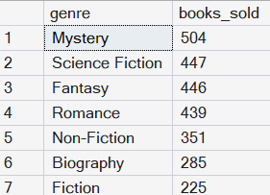
2) Find the average price of books in the "Fantasy" genre
SELECT genre,
FORMAT(AVG(price),'N2') AS Avg_price
FROM books
GROUP BY genre
HAVING genre = 'Fantasy'
Result:
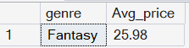

3) List customers who have placed at least 2 orders
SELECT c.customer_id, c.name ,
COUNT(o.order_id) AS order_count
FROM Orders o
JOIN Customers c
ON c.Customer_ID=o.Customer_ID
GROUP BY c.customer_id, c.name
HAVING COUNT(o.order_id) >=2
Result:
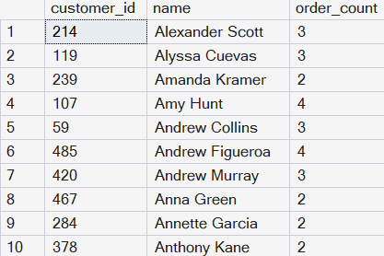

3.b) List customers who have placed orders BETWEEN 3 and 4 times
SELECT c.customer_id, c.name ,
COUNT(o.order_id) AS order_count
FROM Orders o
JOIN Customers c
ON c.Customer_ID=o.Customer_ID
GROUP BY c.customer_id, c.name
HAVING COUNT(o.order_id) BETWEEN 3 AND 4
Result:
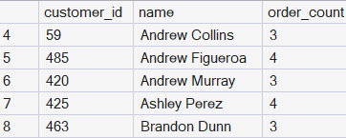
4) Find the most frequently ordered book
SELECT TOP 1 WITH TIES b.title,b.genre, b.author,
COUNT(o.Order_id) AS purchased
FROM orders o
JOIN books b
ON b.book_id=o.book_id
GROUP BY b.title,b.genre,b.author
ORDER BY COUNT(o.Order_id) DESC
Result:
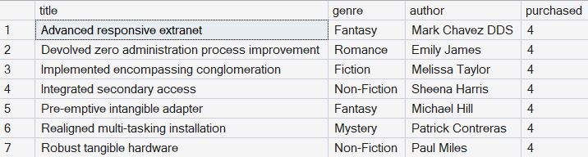

4.a) Find the book with the highest total quantity purchased
SELECT TOP 1 b.title,b.genre,b.author,
SUM(o.quantity) AS purchased
FROM orders o
JOIN books b
ON b.book_id=o.book_id
GROUP BY b.title,b.genre,b.author
ORDER BY SUM(o.quantity) DESC
Result:

5) Show the top 3 most expensive books of 'Fantasy' Genre
WITH expensivebook AS (
SELECT title,genre,FORMAT(price,'N2') AS Cost,
DENSE_RANK() OVER (PARTITION BY genre ORDER BY price DESC) AS Ranking
FROM books)
SELECT * FROM expensivebook
WHERE Ranking <= 3 AND genre = 'Fantasy'
Result:
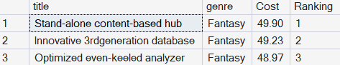

6)Retrieve the total quantity of books sold by each author
SELECT b.Author,
SUM(o.Quantity) AS purchased
FROM orders o
JOIN books b
ON b.book_id=o.book_id
GROUP BY b.Author
ORDER BY SUM(o.Quantity) DESC
Result:
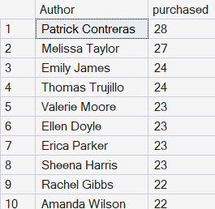

7) List the cities where customers who spent over $30 are located
SELECT C.Customer_ID,c.city,FORMAT(o.total_amount, 'N2') AS spending
FROM Orders o
JOIN Customers c
ON c.Customer_ID = o.Order_ID
WHERE total_amount >= 30
Result:
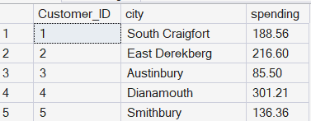

8) Find the customer who spent the most on orders
SELECT TOP 1 c.name,ROUND(o.total_amount, 2)AS spending
FROM Orders o
JOIN Customers c
ON c.Customer_ID = o.Order_ID
ORDER BY spending DESC
Result:


9) Calculate the stock remaining after fulfilling all orders
SELECT b.book_id, b.title,b.stock, COALESCE(SUM(o.quantity),0) AS sold,
b.stock-COALESCE(SUM(o.quantity),0) AS remaining_stock
FROM books b
LEFT JOIN Orders o
ON o.Book_ID=b.Book_ID
GROUP BY b.book_id,b.stock,b.Title
ORDER BY b.book_id
Result:
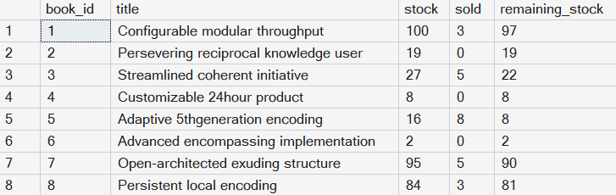

10) Calculate monthly sales performance
SELECT
DATENAME(MONTH,order_date) AS months,
ROUND(SUM(total_amount), 2)AS revenue,
COUNT(order_id) AS orders,
SUM(quantity) AS books_sold
FROM Orders
GROUP BY DATENAME(MONTH,order_date)
ORDER BY SUM(total_amount) DESC;

Result:

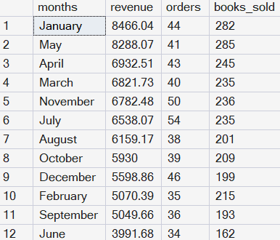

11) Books at risk of running out of stock
WITH stock_details AS (
SELECT b.book_id, b.title,b.stock, COALESCE(SUM(o.quantity),0) AS sold,
b.stock-COALESCE(SUM(o.quantity),0) AS remaining_stock
FROM books b
LEFT JOIN Orders o
ON o.Book_ID=b.Book_ID
GROUP BY b.book_id,b.stock,b.Title),
--SELECT * FROM books_at_risk
stocks_needed AS (
SELECT s.book_id,s.title,s.stock,s.sold,s.remaining_stock,
CASE
WHEN s.remaining_stock <= 0 THEN 'Out of stock'
WHEN s.remaining_stock <= 10 THEN 'Less stock'
ELSE 'Sufficient stock'
END AS stocksdetails
FROM stock_details s)
SELECT * FROM stocks_needed;

Result:

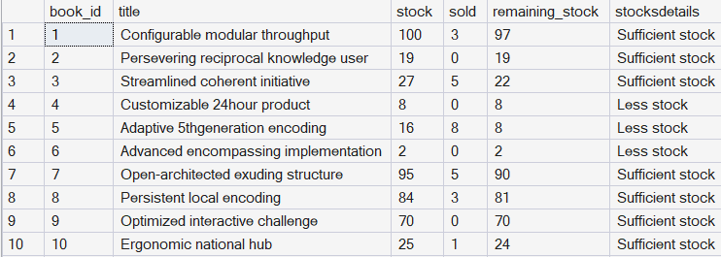

12) Find the highest-spending customer in each country
WITH Country_spending AS (
SELECT c.country,c.name,
FORMAT(SUM(total_amount),'N2') AS spending,
DENSE_RANK() OVER (PARTITION BY c.country ORDER BY SUM(total_amount) DESC) AS ranking
FROM orders
JOIN Customers c
ON c.Customer_ID=Order_ID
GROUP BY
c.country,c.name)
SELECT * FROM Country_spending
WHERE ranking = 1
Result:
